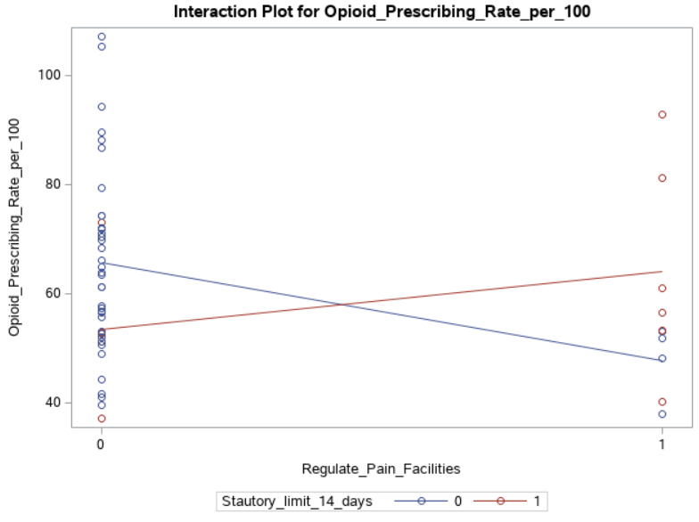

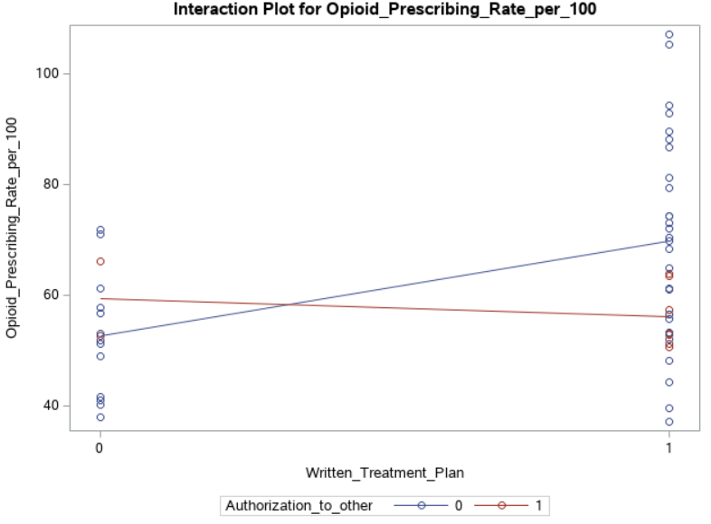

Data description on state policies -

From NAMSDL, we have obtained information regarding state statuses, regulations, and guidelines related to the treatment of chronic pain and prescribing practices such as practitioner education requirements, pain treatment requirements or guidelines, referral of patients, and limitations on the prescribing of Schedule II and Schedule III prescription drugs. We have also gathered information related to regulation of pain clinics and facilities with a focus on the treatment of pain such as registration of pain clinics and treatment facilities, restrictions on who may own a pain clinic or treatment facility, and requirement to have and responsibilities of a medical director.

